Securement Locations
Passengers using mobility devices have priority in securement locations on a first-come-first-serve basis and may request to use either securement location. The bus operator is responsible to prepare the securement area for the mobility device by requesting the seated passengers vacate the area and adjust fold-up seats as necessary.
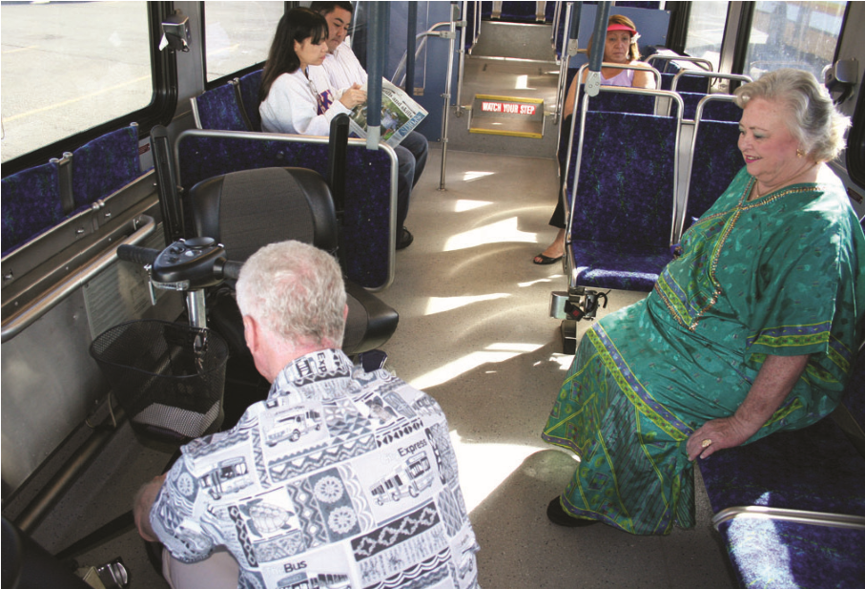

Securing Wheelchairs & Scooters
Bus operators are responsible for securement of mobility devices aboard TheBus vehicles. Company policy requires a minimum four-point tie-down be used to ensure safe transport of mobility devices. The device will be secured at two points on the rear of the device and at least two points on the front. If the tie-down points are not obvious, bus operators are trained to ask mobility device users where the best tie-down points for their device would be. Because of special equipment or design limitations, it may not be possible to secure some devices with the minimum four tie-downs. (See Tie-Down Point Identification Program)
Most scooters are not designed to be trans-ported on a bus and can be very unstable even when secured. It is strongly recommended that scooter users transfer to a bus seat, if possible, to avoid tipover accidents.
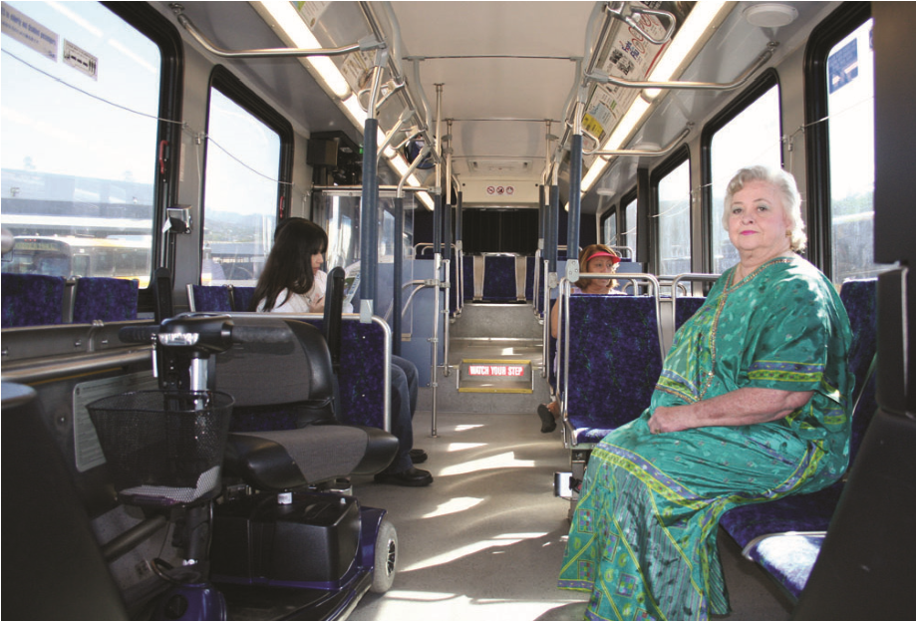
Tie-Down Point

Identification Program
TheBus has implemented a program to assist with the securement of mobility devices by identifying tie-down points using tether straps or yellow tape to ensure timely and proper securement. By appointment, TheBus Training Department Staff will examine your mobility device and determine the best securement points. The securement points will then be marked with color-coded tape.
Securement points, which can easily accommodate securement devices, will be marked with YELLOW tape. Securement points that are of an irregular size or in a difficult area to access will be marked with BLUE color tape. Tether straps will be attached to the mobility device identified with BLUE color tape. These heavy-duty, bright yellow straps can be used in conjunction with wheelchair securement devices in all TheBus buses.
Not all mobility aids will need to use tether straps. In most cases, the mobility device will only need the yellow tape to mark the best securement points. Tether straps will be issued at NO CHARGE to riders with mobility devices that require them.
For more information or to schedule an appointment, contact the Oahu Transit Services, Inc. Customer Service at (808) 848-5555, press 3. All appointments will be held at the Oahu Transit Service, Inc., Training Department, located in Building C, 811 Middle Street, Honolulu, HI 96819.

Seat Belts & Shoulder Harnesses
Seat belts and shoulder harnesses are provided on all buses. Passengers should inform the bus operator if they want to use the seat belt and/ or shoulder harness. Bus operators will provide assistance with the use of the seat belt and the shoulder harness to ensure proper positioning and securement. Bus operators may request the assistance of the passenger to minimize the possibility of any unwanted physical contact.

Service Animals
Service animals are allowed on all TheBus vehicles and in all TheBus facilities.

Personal Care Attendant
A personal care attendant (PCA) designated or employed specifically to help the person with a disability meet their personal needs shall pay no fare when performing the service.

Announcing Bus Stops
All buses are equipped with an Automatic Next Stop announcement system which calls out the ADA-required announcements inside the bus.
All buses are also equipped with an Automatic Exterior announcement system that announces the route number and destination outside the bus each time the front door is opened.
If either of the automatic announcement systems become inoperable, the bus operator is responsible to make the ADA-required announcements.

Bus Operator Training
All bus operators receive initial and periodic refresher training on TheBus policies and procedures for persons with disabilities. Bus operators are trained to be proficient in the safe operation of the vehicle as well as all securement and accessibility equipment aboard the vehicle. Bus operators are also trained to properly assist persons with disabilities and treat them in a respectful and courteous manner.

TheHandi-Van Paratransit Service
TheHandi-Van is a public transit service for persons with disabilities who are unable to use the City’s bus service, TheBus. Individuals who are interested in using TheHandi-Van service will participate in an in-person interview during which their abilities to use TheHandi-Van and TheBus will be assessed.
TheHandi-Van Eligibility Center is located in the First Insurance Center at 1100 Ward Avenue, Suite 835, in Honolulu. The Center is open Monday through Friday from
8:30 a.m. to 4:00 p.m. Please call (808) 538-0033 for more information or to schedule an in-person interview.
Revised Sept 2022

Accessible Bus

Rider’s Guide
TheBus welcomes you aboard our entire fleet of accessible fixed route buses. We provide to our passengers with disabilities comparable services to that of all other passengers. The policies outlined in this brochure allow us to provide safe, accessible, efficient and dependable service driven by the Spirit of Aloha. Enjoy the ride!

Accessible Buses
All buses meet Americans with Disabilities Act (ADA) requirements and are equipped with lifts or ramps and a kneeling feature. Bus operators are trained to deploy the lift or kneeling features at major bus stops or upon request. When the bus comes to a stop, please inform the operator that you want to use the lift or kneeling feature.
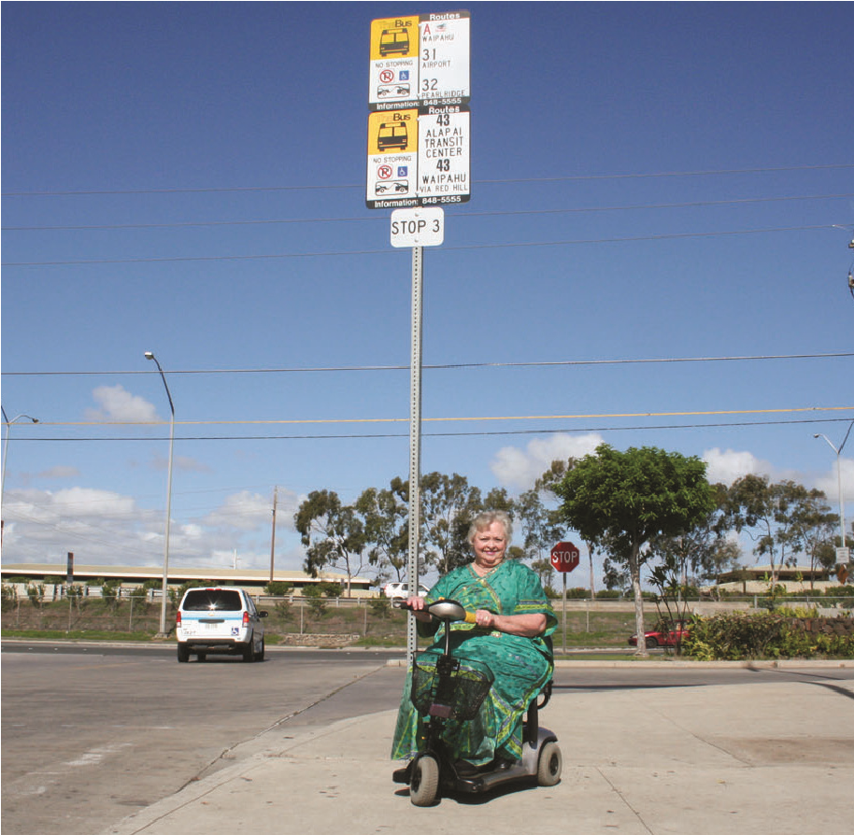
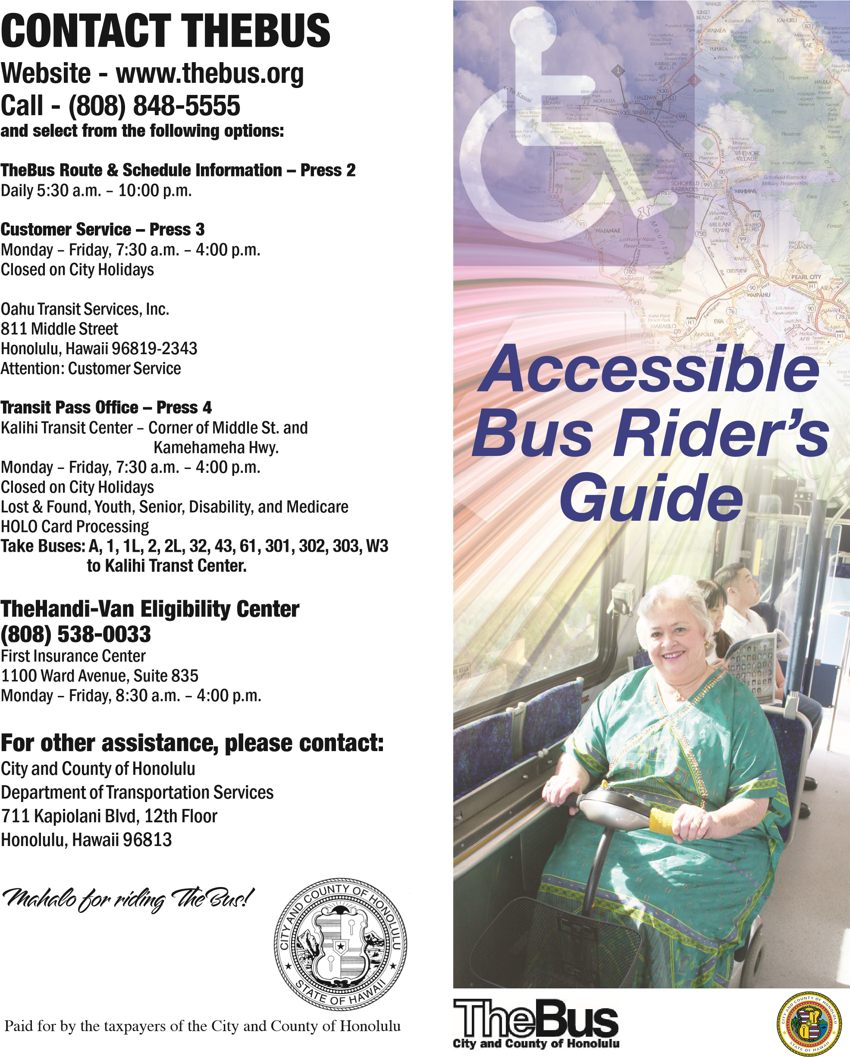
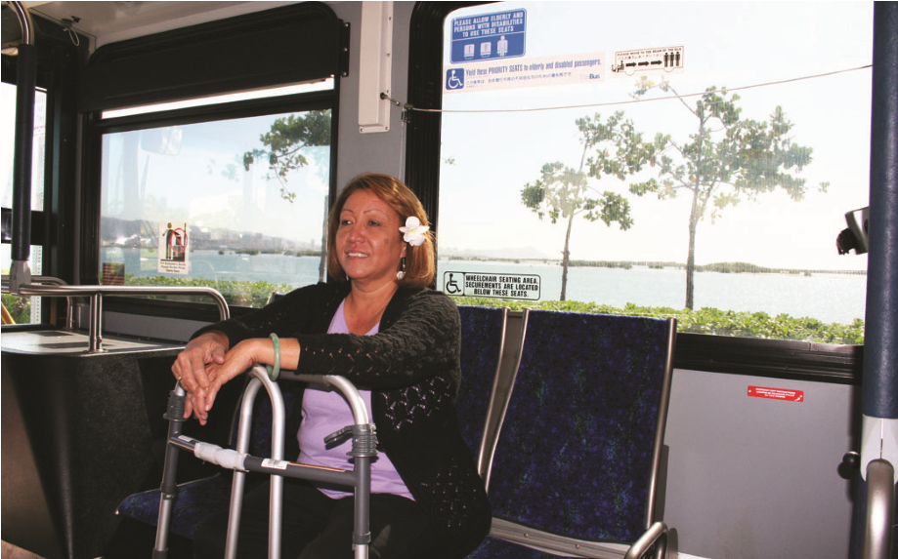
Boarding & Deboarding
Passengers may request to use the lift or ramp at any designated bus stop. The bus operator may determine that the bus stop is not a safe area to deploy the lift or ramp, in which case the operator shall inform the passenger that the bus will move to a safer place for boarding or alighting.
Bus operators are trained to provide assistance to passengers up or down stairwells, to and from their seats, or to negotiate lifts or ramps if requested.

Transporting Mobility Devices
Bus operators will make every reasonable effort to transport any mobility device that fits on the lift or ramp and can be safely secured within the securement area. Mobility devices that do not fit aboard our buses will not be transported.

Priority Seats
Priority seats are designated for persons with disabilities, the elderly, and women in advanced stages of pregnancy on a first-come-first-serve basis. Bus operators will provide assistance with finding a seat upon request.

